DIARY PROJECT PLAY
- Loaded the raw MCDI dataset (CSV file from Wordbank) into R and stored it in the data folder.
- Created longitudinal data -- Filtered the dataset to keep only children with data for four or more ages, creating a longitudinal subset of the data.
- Fitted a logistic regression model using value (whether a word is known) as the dependent variable and age as the predictor.
  - Created a plot showing the fitted logistic curve, with age on the x-axis and probability of knowing a word on the y-axis.
- Mixed effect model on logistic regression model as we need to know the random effects
  - RANDOM INTERCEPTS MODEL
    - Random effect capture vriability of item difficulty
- Running logistic model with var=age as a non-linear predictor
- Compare models anova(mixed_log_reg, mixed_log_reg_nonlinear):
  - mixed_log_reg: RANDOM INTERCEPTS MODEL --> VARIABILITY OF WORDS & CHILD (age is a LINEAR PREDICTOR)
  - mixed_log_reg_nonlinear: RANDOM INTERCEPTS MODEL --> VARIABILITY OF WORDS & CHILD (age is a NON-LINEAR PREDICTOR)

STEPS FOR NEXT WEEK
- Compare models anova(mixed_log_reg, mixed_log_reg_nonlinear):
  - mixed_log_reg: RANDOM INTERCEPTS MODEL --> VARIABILITY OF WORDS & CHILD (age is a LINEAR PREDICTOR)
  - mixed_log_reg_nonlinear: RANDOM INTERCEPTS MODEL --> VARIABILITY OF WORDS & CHILD (age is a NON-LINEAR PREDICTOR)

- Copy Layla’s Rscript
  - 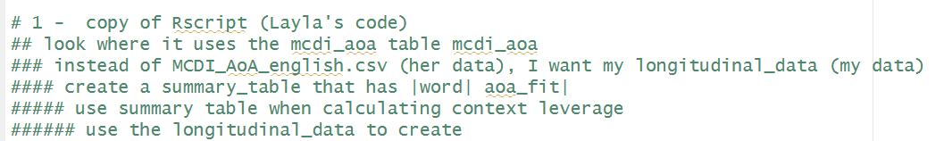
- Create a summary_table that has |word| aoa_fit| from my longitudinal_data
  - use summary table when calculating context leverage
- 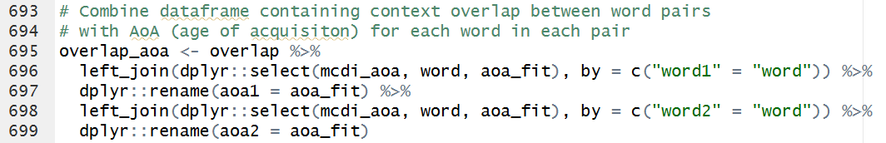
  - Change …. With my summary_table

- actual calculation of context leverage . UNCHAGED --> CONTEXT LEVERAGE
  - 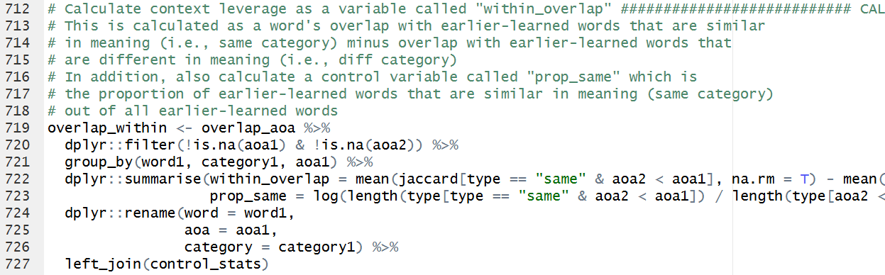
- merge overlap_aoa (CONTEXT LEVERAGE) with the longitudinal_data --> NEW BIT
- K

Step 4
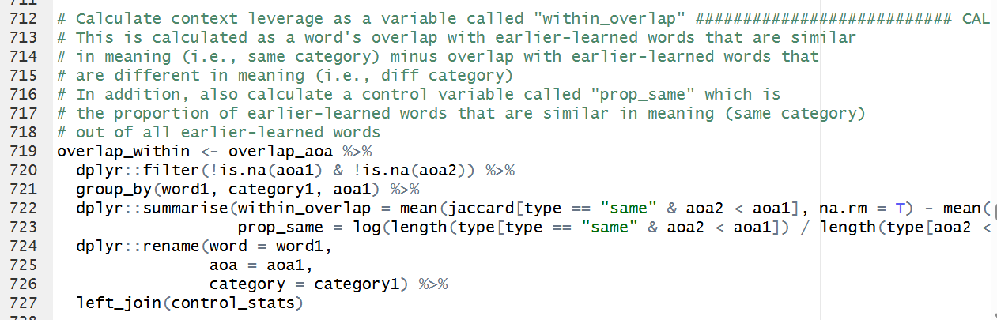

# 1 - copy layla's script
# 2 - create summary_table (word, aoa_fit) from my longitudinal_data --> USE DISTINCT to eliminate doubles
# 3 - start calculating CONTXT LEVERAGE using my summary_data

# Combine dataframe containing context overlap between word pairs
# with AoA (age of acquisiton) for each word in each pair
overlap_aoa <- overlap %>%
left_join(dplyr::select(summary_table, word, aoa_fit), by = c("word1" = "word")) %>%
dplyr::rename(aoa1 = aoa_fit) %>%
left_join(dplyr::select(summary_table, word, aoa_fit), by = c("word2" = "word")) %>%
dplyr::rename(aoa2 = aoa_fit)

# 4 - actual calculation UNCHAGED --> CONTEXT LEVERAGE

# 5 - - merge overlap_aoa (CONTEXT LEVERAGE) with the longitudnal_data --> NEW BIT

1 - scaling all the vars (z-scores) – WE SHOULDN’T SCALE AGE because it is a baeline var predictor. We don’t use it to compare it with other variables but rather it is a our focus predictor
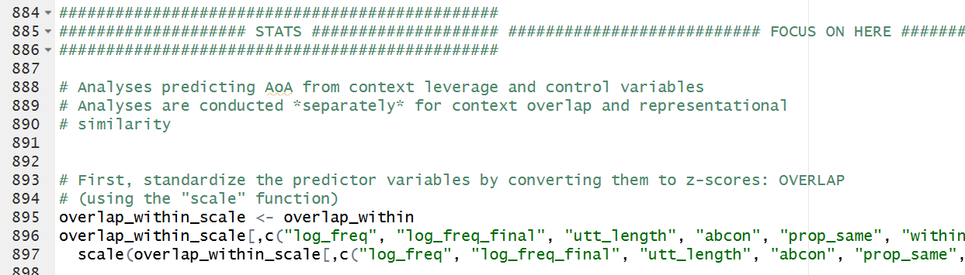

2 – regression model
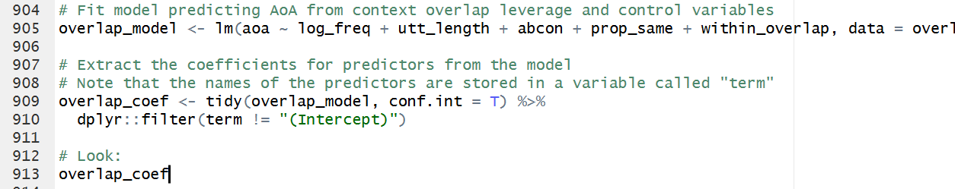
BUT
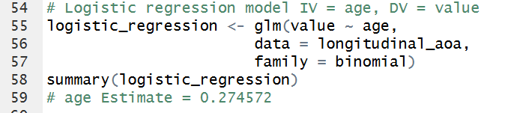
INCLUDE COMPARISON BETWEEN MODELS RUN THE COMPARISON
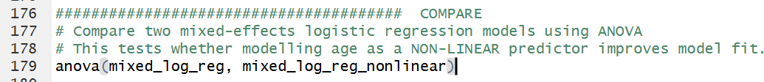
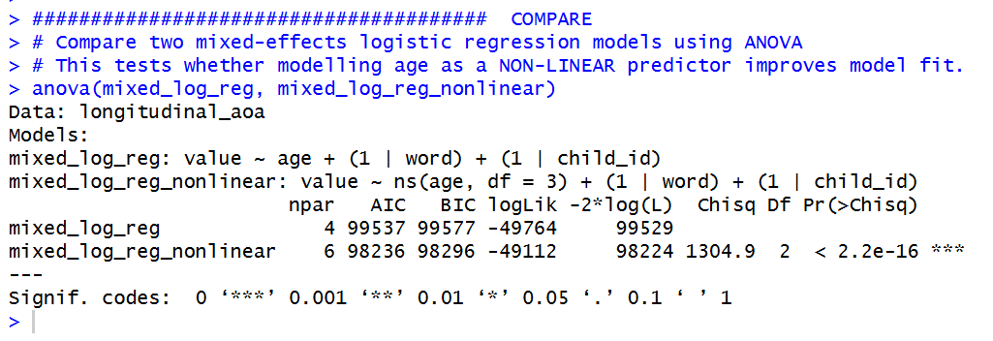
EITHER LINEAR or NON-LINEAR AS PREDICTOR

BASE MODEL
USING glmer() AGE NON LINEAR PREDICTOR
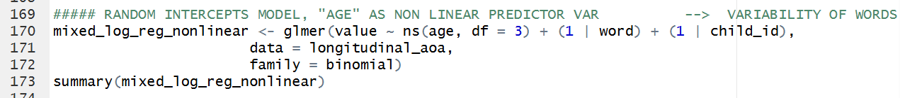

ADDING CONFOUNDING VARS and also CONTEXT LEVERAGE (overlap_wthin)
RUN LOGISTIC REGRESSION MODEL WITH ALL VARS
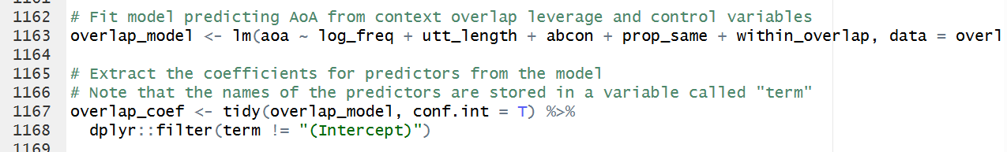

Look at these vars and see which one has a main effect or all of them
effect of vars by comparing models with diff number of vars

GRAPH WITH ALL THE VARS

LOOK AT INTERACTIONS BETWEEN AGE AND each one of the confounding variable

EASTER TIME

- Running interactions and DECIDE which vars should be included in our final model
- Create a diary to document (OUTLINE OF THE PROCESS) each step of the process, along with results that justify decisions made
  - OUTLINE OF THE KEY FINDINGS OF THE ANALYSIS
    - BASIS FOR MY RESULTS SECTION
- LOOK AT LAYLA’S and understand how to write each section
- Method about describing the vars and how you calculate them (just about the variables NOT MODEL COMPARISON)
- Results outcome of what you did in the method (MODEL COMPARISON, I included age non linear)

- Graph woth all vars, remove age, and the intercept. Use the winner model
  - 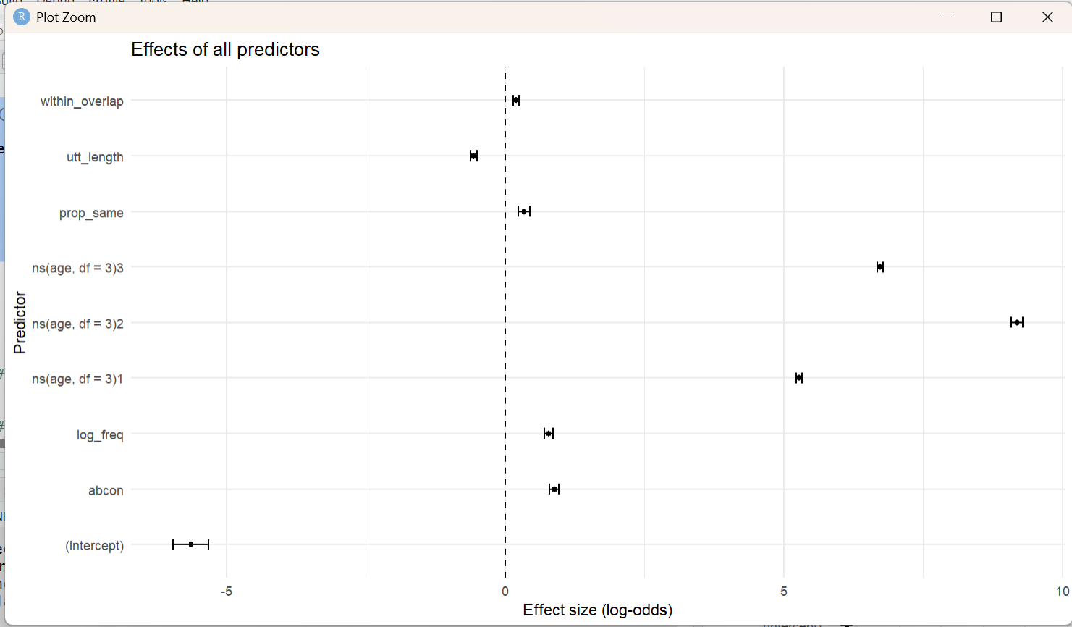

- Graph sigmoid showing age
  - 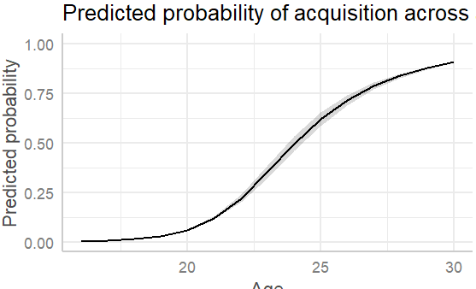
- Graph no interaction context leverage. Plot the graph with two lines (high & low)
- Graph with int (lo-freq)
- Graph with int (lo-freq)
- Graph with int (lo-freq)
- Graph with int (lo-freq)
- Graph with int (lo-freq)
Create a multipanel showing all the 5 graphs above (joining graphs)
Customise them

Plot the final model including only 1 predictor, the s curve, accounting for the non-linear variation of age
Do the same for each var
Plot within_ovelap with no interaction.

- Check data camp accessibility
- Get rid of the median on each plot
- Set up the GitHub
Create a special folder
Same set as DV exam
Link GitHub project to r studio project
Careful to any large data files, you might want to decide not to push them to the repository (gitignore)
Maybe don’t save the Raw data sets into the repository (github) as they are very large files, you can save the longitudinal data data sets as it is smaller and maybe small enough to be in the repository

INTRODUCTION

METHODS (1500)
How you calculated and generated the vars (very similar to Layla’s)
How we got the vars we need
You use longitudinal data that differs from Laila’s

RESULTS (1500)
Everything new that I did (from the STAT BEGINNING bit: justify random intercept model, etc)
How we got the final model

DISCUSSION

CONCLUSION

WRITING BIT

Method section

